**Draw the DFD to be considered while codding the individual processes or functions.**

Table of Contents

1.) Introduction 2

2.) Level 0 DFD (Context Diagram) 2

2.3) Data Flow 2

3.) Level 1 DFD (User Processes) 3

3.1) Entities 3

3.2) Processes 3

3.3) Data Flow 3

4.) Level 2 DFD (Detailed Processes) 4

4.1) Entities 4

4.2) Processes 4

4.3) Data Flow: 4

5.) DFD Diagrams 5

5.1.) Level-0 DFD 5

# Introduction

Creating a Data Flow Diagram (DFD) for a software application like the Expense Analyzer App is a complex task and usually involves multiple levels of DFDs to represent the data flow within the system. I can provide you with a high-level overview of what a DFD for this type of app might look like, but keep in mind that a comprehensive DFD might require more details and levels.

Here's a simplified DFD for the Expense Analyzer App:

1. Level 0 DFD (Context Diagram)
   * This is the highest-level DFD, representing the system as a single process.
   * It shows interactions between the system (the Expense Analyzer App) and external entities.

2.1.) Entities

1. User

2. Database (where expense data is stored)

3. Expense Analyzer App

2.2) Processes

* User interacts with the Expense Analyzer App to perform tasks like registration, expense entry, and reporting.
* The Expense Analyzer App communicates with the database to store and retrieve expense data.

# 2.3) Data Flow

* User inputs and retrieves data from the Expense Analyzer App.
* The Expense Analyzer App interacts with the database to save and retrieve expense data.

# Level 1 DFD (User Processes)

* At this level, you can break down the User process into more detailed sub-processes.

## 3.1) Entities

1. User

2. Database

3. Expense Analyzer App

## 3.2) Processes

1. User Registration

2. User Login

3. Enter Expense

4. View Expense Report

5. Generate Expense Summary

6. Logout

## 3.3) Data Flow

* + - User interacts with the Expense Analyzer App to perform specific tasks.
    - The Expense Analyzer App communicates with the database as needed to retrieve or update expense data.

# Level 2 DFD (Detailed Processes)

If needed, you can further break down each user process into more detailed sub-processes. For example, the "Enter Expense" process might involve data validation, category selection, and more.

## 4.1) Entities

1. User

2. Database

3. Expense Analyzer App

## 4.2) Processes

1. User Registration

- Validate User Data

- Create User Account

2. User Login

- Verify User Credentials

- Grant Access

3. Enter Expense

- Validate Expense Data

- Categorize Expense

- Save Expense Data

4. View Expense Report

- Retrieve Expense Data

- Display Expense Report

5. Generate Expense Summary

- Calculate Expense Totals

- Generate Summary Report

6. Logout

## 4.3) Data Flow:

* + Each sub-process communicates with the Expense Analyzer App and may involve interactions with the database.

Please note that this is a simplified representation, and in practice, DFDs can become more complex as you delve deeper into the application's functionality and data flow. Creating a comprehensive DFD often involves collaboration with stakeholders and subject matter experts to ensure accuracy and completeness.

# DFD Diagrams

## 5.1.) Level-0 DFD

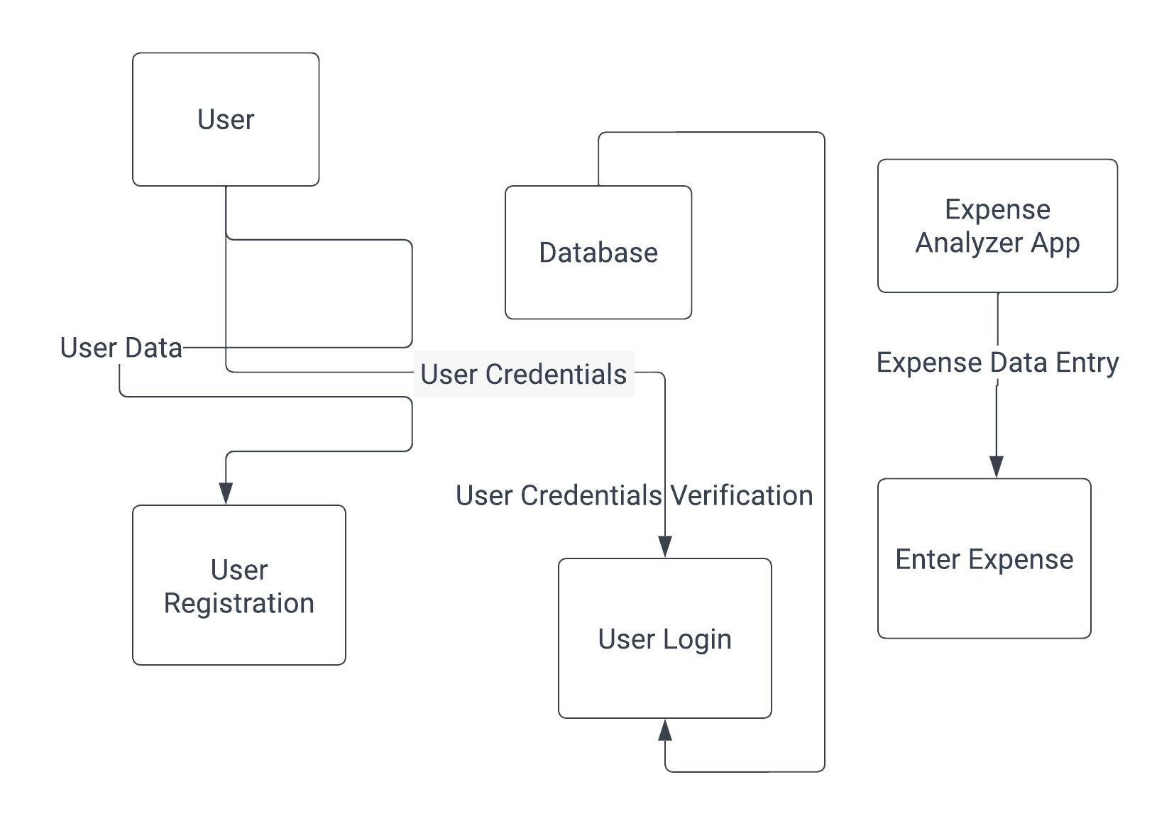

Figure 1 user login credentials and expense entered by user